Welcome!
St. Mary Parish Catholic
School

St. Mary Parish Catholic School •2026-27
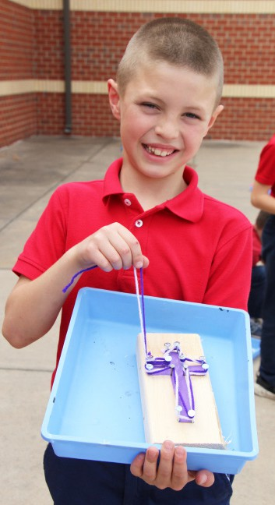
We are thrilled by your interest in enrolling your children at St. Mary Parish For Catholic families, the enrollment process is straightforward:

faith academic
service
Catholic School!
- Begin by registering at our parish. You can initiate this process by emailing parish@stmarysderby.com or calling the parish office at
316-788-5525 to schedule an appointment.
- Engage in regular attendance at Mass and embrace Stewardship as a fundamental aspect of your lifestyle. This involves active participation in at least one ministry and starting to tithe.
- If you didn’t attend the Kindergarten parent meeting you will need to arrange a meeting with Principal, Christopher Korbe and Father Michael Linnebur. To schedule a meeting with Mr. Korbe, please contact Allison at 316-788-3151 or alesley@stmarysderby.com. To schedule a meeting with Father Michael call the parish office at 316-788-5525.

For non-Catholic families interested in joining St. Mary School on a tuition basis, the process is even simpler. Just reach out to the school office at
316-788-3151.

For more detailed information, please visit our website at www.stmarysderby.
2306 E Meadowlark
Derby 67037
Ph: 316-788-3151
Fax: 316-788-6895
stmarysderby.com
com, where you can also find our student handbook.
We sincerely appreciate your decision to entrust your child’s education to St. Mary Parish Catholic School. It’s a privilege bestowed upon us by God through the support and dedication of our parish community.
– – – – – – – – – – – – – – – – – – – – – – – – – – – – – – – – – – – – – –

Giving without spending a dime!
St. Mary Parish Catholic
School

St. Mary Parish Catholic School •2026-27
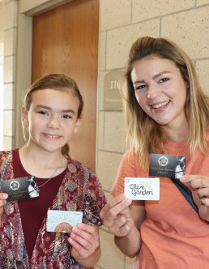

SCRIP AND DILLONS PLUS CARD COMMUNITY REWARDS benefit
the parish financially without you spending an extra dime. And they’re easy!
How?
- SCRIP - Simply buy Scrip cards (gift cards) at the school office or after Mass on Sundays for merchants you regularly patronize. You can use the full amount of the card to shop, and St Mary receives a percentage of the card value directly from the merchant. It’s a HUGE help to the parish! Even easier, you can buy and use Scrip from your smart phone while you’re at a store anywhere in the country, or from your home computer. It’s two steps, 1) to set up your Scrip account at shopwithscrip.com to benefit 5F2DB88614475 (St Mary Altar Society), and 2) to authorize payments to be debited to your checking account. Once it’s set up, it just takes seconds from wherever you are to order and use Scrip, though! Instructions are at tinyurl. com/y7hunvd2, or contact Judy, 316-788-4945. She loves the program, and
can help you set up an account and add the app to your phone!
- DILLONS COMMUNITY REWARDS: Sign in or create an account at dillons.com/communityrewards, and designate that community rewards from purchases with your PLUS card go to HK211 (St. Mary Derby PTO) OR call Dillons Customer Service, (800)576-4377, option 3, and choose HK211 for your community rewards! It’s fast, easy, costs you nothing and helps St Mary! Every time you swipe your PLUS card or enter your alternate ID (your phone#), you benefit St Mary! [Dillons doesn’t give St Mary as high a percentage as SCRIP, so if you’re buying gift cards, do it through the Scrip program when possible, and if that’s not doable, buy them through Dillons.] You don’t spend anything extra, and your normal shopping benefits YOUR child’s school! That’s awesome! Thank you for using Scrip and
2306 E Meadowlark
Derby 67037
Ph: 316-788-3151
Fax: 316-788-6895
Stmarysderby.com
Dillons rewards programs!

2306 E Meadowlark
Derby 67037
Ph: 316-788-3151
Fax: 316-788-6895
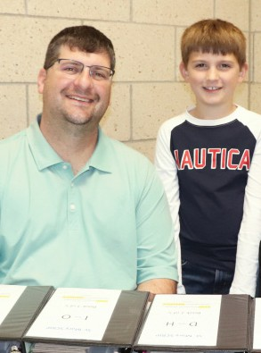
stmarysderby.com

– – – – – – – – – – – – – – – – – – – – – – – – – – – – – – – – – – – – – – – – – – – – – – – –

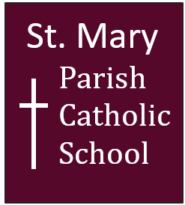
Paying fees

St. Mary Parish Catholic School • 2026-27

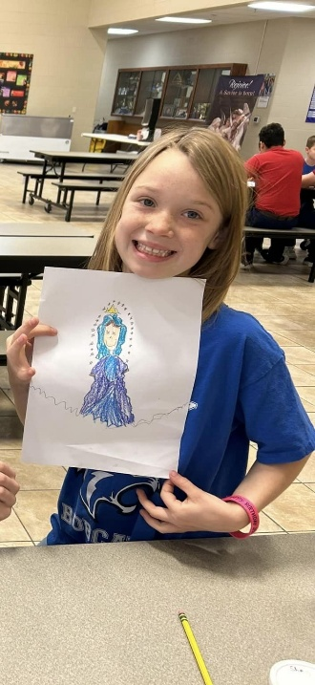
St Mary Parish Catholic School accepts payment of fees via:
- Visa, MasterCard, or Discover, payable in the school office.
- Electronic Funds Transfer
- Cash or Check (made payable to “St Mary School,” please).
Once your child is enrolled, you can be set up with an EZschoolpay.com account that will allow online payments for your family’s school lunch payments and for future school fees. More information will be given to you at that time about how to use EZschoolpay.com.
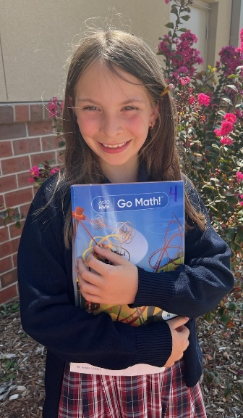
Got Questions?
Contact Allison Lesley, 788-3151 (M-F 7:30 am to 4 pm) or

ith academics
service
alesley@stmarysderby.com.
One last thing!
If you prefer to process your transactions in person, you can always do
so by visiting Allison at the school office.

– – – – – – – – – – – – – – – – – – – – – – – – – – – – – – – – – – – – – – – – – – – – – – – –

FAQ
St. Mary Parish Catholic
School

St. Mary Parish Catholic School • 2026-27

Hours
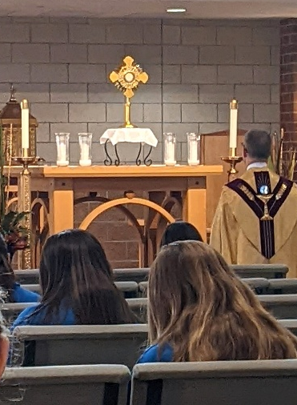
- School: Children may arrive for school starting at 7:30 am Students go to classrooms at 7:45 to start desk work; class starts promptly at 7:55. School is out at 3:20. For drop off and pick up, parents should pull into the parking lot through the east entrance, and pull forward as far as possible. Students will receive 2 family name signs at Open House and when parents pull into the parking lot to pick up students, they will need to show their family sign and students will be called out of school by family.
faithervice

5-day PK: 8:30-11 am, or 8:30 am-3:20 pm
- Latchkey students can be picked up in the school Commons after school. Latchkey hours & cost:
K-8: 6:30-7:30 am in the school Commons and 3:20-5:30 pm, $5/hour PK: 7:30-8:30 am in classroom (enter through playground gate) and 3:20- 5:30 pm, Pick-up in school commons. $5/hour

School Massr
Parents are invited to attend daily Mass (Mon-Fri) with students. Parents are asked to sit at the back of church, not with their child.
faith
aith
ffff

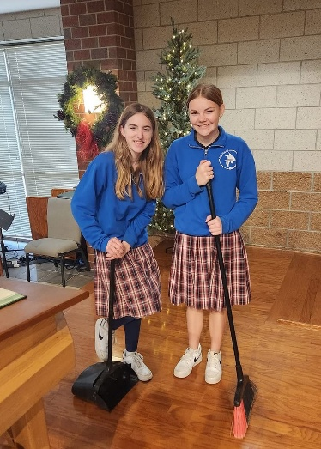
Dress code
Girls and boys may wear navy blue pants year-round, or walking length shorts (just above the knee) during 1st quarter and 4th quarter. Pants/shorts must have belt loops and be worn with a dark brown or black belt which is in the belt loops and free of trim. Girls also have the option to wear St Mary plaid uniform skirts (K-5 has straps/top section), with shorts under the skirt. No tight or too short.
Middle school students are required to have a P.E. uniform shirt and navy shorts, not tight or too short.
Shirts: White button-down or polo shirt (short or long sleeved), must be tucked in at the waist at all times. Navy (girls) and red (boys) polo shirts are also allowed. School shirt may be worn underneath school sweatshirts. No emblems of any kind are allowed.
service
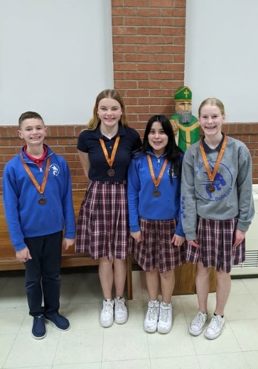
Navy blue cardigans, vests and pullover sweaters, or gray long-sleeved sweatshirts with the St. Mary school emblem may be worn over a uniform shirt or turtleneck. Students can also wear blue ¼ zip sweatshirts and blue or gray crewneck Bobcat sweatshirts in the classroom. St Mary sweatshirts and spirit shirts for Spirit Days (usually the first Friday) can be purchased through bbscreationsict.com.
Socks must be black, navy or white, without trim. Leather dress shoes (closed heel, brown, black or navy), or tennis shoes are the required footwear. Tennis shoes should be mostly white, black, navy, or gray, with matching white or black laces. Students may wear leather shoes and change into tennis shoes for P.E. The complete dress code and handbook can be found online at stmarysderby.com/parents-students/handbook- forms.
PE shirts can be purchased through the office (see fee sheet). Used uniforms can be purchased in July at school. New uniforms can be purchased through Schoolbelles, schoolbelles.com or 1-888-637-3037 (St Mary: S2782).
academicss

Lunches
Parents have a family account. Pay by sending a check to school or go online and use EZschoolpay.com. A child’s school lunch is $4 which includes a milk, .90 cents for an a la carte milk.
2306 E Meadowlark
Derby 67037
Ph: 316-788-3151
Fax: 316-788-6895
stmarysderby.com

Any other questions? Call Allison @ 316-788-3151!

Required forms
St. Mary Parish Catholic
School
St. Mary Parish Catholic School • 2026-27


Admission is not complete until you have returned ALL required forms listed below.
- Parish Stewardship Commitment

- New Student Enrollment Application

- 2025 Time, Talent and Treasure forms

- Please provide copies of:
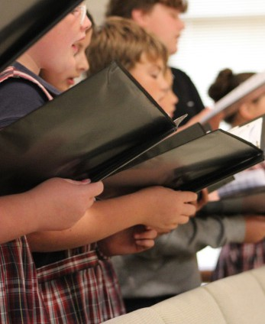
  - Birth Certificate
  - Baptism Certificate
  - Immunization Record

- Health Assessment Form signed by licensed physician

- Fee Schedule, with payment or payment plan

- School transfer forms as needed

  - St. Mary will request school records for your student

$50 per student is due upon application; final balance is due by July 9 (or contact the school office 316-788-3151 about a payment plan by July 9).

2306 E Meadowlark
Derby 67037
Ph: 316-788-3151
Fax: 316-788-6895
stmarysderby.com

